**Ethernet Cable**

An ethernet cable allows the user to connect their devices such as computers, mobile phones, routers, etc.; to a network that will allow a user to have internet access, it also carries broadband signals between devices connected through it.

# Network Devices (Hub, Switch, Router)

* Network devices, also known as networking hardware, are physical devices that allow hardware on a computer network to communicate and interact with one another.

1. **Hub** –

* A hub is a basically multi-port repeater.
* A hub connects multiple wires coming from different branches, for example, the connector in star topology which connects different stations.
* Hubs cannot filter data, so data packets are sent to all connected devices.
* In other words, the [collision domain](https://en.wikipedia.org/wiki/Collision_domain) of all hosts connected through Hub remains one.
* Also, they do not have the intelligence to find out the best path for data packets which leads to inefficiencies and wastage.

1. **Switch** –

* A switch is a multiport bridge with a buffer and a design that can boost its efficiency(a large number of ports imply less traffic) and performance.
* A switch is a data link layer device.
* The switch can perform error checking before forwarding data, which makes it very efficient as it does not forward packets that have errors and forward good packets selectively to the correct port only.
* In other words, the switch divides the collision domain of hosts, but the [broadcast domain](https://en.wikipedia.org/wiki/Broadcast_domain) remains the same.

1. **Routers** –

* A router is a device like a switch that routes data packets based on their IP addresses.
* The router is mainly a Network Layer device.
* Routers normally connect LANs and WANs and have a dynamically updating routing table based on which they make decisions on routing the data packets.
* The router divides the broadcast domains of hosts connected through it.

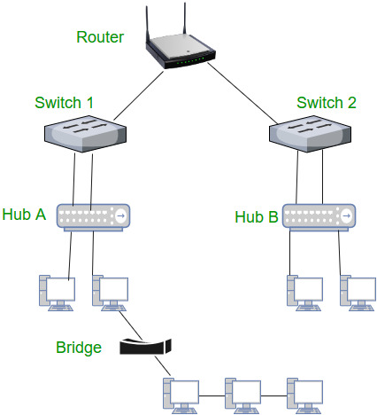

**Network Topology** is the way that defines the structure, and how these components are connected to each other.

## **Types:**

* The arrangement of a network that comprises nodes and connecting lines via sender and receiver is referred to as **Network Topology**.
* The various network topologies are:
* Point to Point Topology Mesh Topology
* Star Topology Bus Topology
* Ring Topology Tree Topology
* Hybrid Topology

### Point to Point Topology

* It works on the functionality of the sender and receiver.
* It is the simplest communication between two nodes, in which one is the sender and the other one is the receiver.
* Point-to-Point provides high bandwidth.

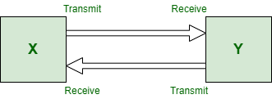

### Mesh Topology

* In this topology, every device is connected to another device via a particular channel.
* In [Mesh Topology](https://www.geeksforgeeks.org/difference-between-star-and-mesh-topology/), the protocols used are AHCP (Ad Hoc Configuration Protocols), DHCP (Dynamic Host Configuration Protocol), etc.

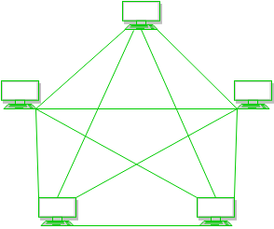

**Advantages:**

* Communication is very fast between the nodes.
* Mesh Topology is robust.
* The fault is diagnosed easily. Data is reliable because data is transferred among the devices through dedicated channels or links.
* Provides security and privacy.

**Drawbacks:**

* Installation and configuration are difficult.
* The cost of cables is high as bulk wiring is required, hence suitable for less number of devices.
* The cost of maintenance is high.
* A common example of mesh topology is the internet backbone, where various internet service providers are connected to each other via dedicated channels.
* This topology is also used in military communication systems and aircraft navigation systems.

### Star Topology

* In [Star Topology](https://www.geeksforgeeks.org/difference-between-star-and-ring-topology/), all the devices are connected to a single hub through a cable.
* This hub is the central node and all other nodes are connected to the central node.
* The hub can be passive in nature i.e., not an intelligent hub such as broadcasting devices, at the same time the hub can be intelligent known as an active hub.
* Active hubs have repeaters in them.
* Coaxial cables or RJ-45 cables are used to connect the computers.
* In Star Topology, many popular Ethernet LAN protocols are used as CD(Collision Detection), CSMA (Carrier Sense Multiple Access), etc.

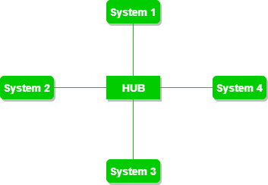

**Advantages:**

* If N devices are connected to each other in a star topology, then the number of cables required to connect them is N. So, it is easy to set up.
* Each device requires only 1 port i.e. to connect to the hub, therefore the total number of ports required is N.
* It is Robust. If one link fails only that link will affect and not other than that.
* Easy to fault identification and fault isolation.
* Star topology is cost-effective as it uses inexpensive coaxial cable.

**Drawbacks:**

* If the concentrator (hub) on which the whole topology relies fails, the whole system will crash down.
* The cost of installation is high.
* Performance is based on the single concentrator i.e. hub.
* A common example of star topology is a local area network (LAN) in an office where all computers are connected to a central hub.
* This topology is also used in wireless networks where all devices are connected to a wireless access point.

### Bus Topology

* It is a network type in which every computer and network device is connected to a single cable.
* It is bi-directional.
* It is a multi-point connection and a non-robust topology because if the backbone fails the topology crashes.
* In Bus Topology, various MAC (Media Access Control) protocols are followed by LAN ethernet connections like TDMA, Pure Aloha, CDMA, Slotted Aloha, etc.

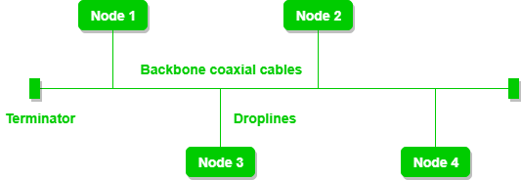

**Advantages:**

* If N devices are connected to each other in a bus topology, then the number of cables required to connect them is 1, known as backbone cable, and N drop lines are required.
* Coaxial or twisted pair cables are mainly used in bus-based networks that support up to 10 Mbps.
* The cost of the cable is less compared to other topologies, but it is used to build small networks.
* Bus topology is familiar technology as installation and troubleshooting techniques are well known.
* [CSMA](https://www.geeksforgeeks.org/carrier-sense-multiple-access-csma/) is the most common method for this type of topology.

**Drawbacks:**

* A bus topology is quite simpler, but still, it requires a lot of cabling.
* If the common cable fails, then the whole system will crash down.
* If the network traffic is heavy, it increases collisions in the network. To avoid this, various protocols are used in the MAC layer known as Pure Aloha, Slotted Aloha, CSMA/CD, etc.
* Adding new devices to the network would slow down networks.
* Security is very low.
* A common example of bus topology is the Ethernet LAN, where all devices are connected to a single coaxial cable or twisted pair cable.
* This topology is also used in cable television networks.

### Ring Topology

* It forms a ring connecting devices with exactly two neighboring devices.
* A number of repeaters are used for Ring topology with a large number of nodes, because if someone wants to send some data to the last node in the ring topology with 100 nodes, then the data will have to pass through 99 nodes to reach the 100th node.
* Hence to prevent data loss repeaters are used in the network.
* The data flows in one direction, i.e. it is unidirectional, but it can be made bidirectional by having 2 connections between each Network Node, it is called Dual Ring Topology.
* In-Ring Topology, the Token Ring Passing protocol is used by the workstations to transmit the data.

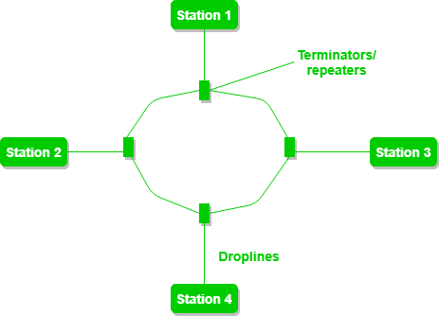

* **Token passing:**It is a network access method in which a token is passed from one node to another node.
* **Token:**It is a frame that circulates around the network.

**Operations of Ring Topology**

1. One station is known as a **monitor** station which takes all the responsibility for performing the operations.
2. To transmit the data, the station has to hold the token. After the transmission is done, the token is to be released for other stations to use.
3. When no station is transmitting the data, then the token will circulate in the ring.
4. There are two types of token release techniques: **Early token release** releases the token just after transmitting the data and **Delayed token release** releases the token after the acknowledgment is received from the receiver.

**Advantages:**

* The data transmission is high-speed.
* The possibility of collision is minimum in this type of topology.
* Cheap to install and expand.
* It is less costly than a star topology.

**Drawbacks:**

* The failure of a single node in the network can cause the entire network to fail.
* Troubleshooting is difficult in this topology.
* The addition of stations in between or the removal of stations can disturb the whole topology.
* Less secure.

### ****Tree Topology****

* This topology is the variation of the Star topology.
* This topology has a hierarchical flow of data.
* In [Tree Topology](https://www.geeksforgeeks.org/difference-between-star-topology-and-tree-topology/), protocols like DHCP and SAC (Standard Automatic Configuration ) are used.

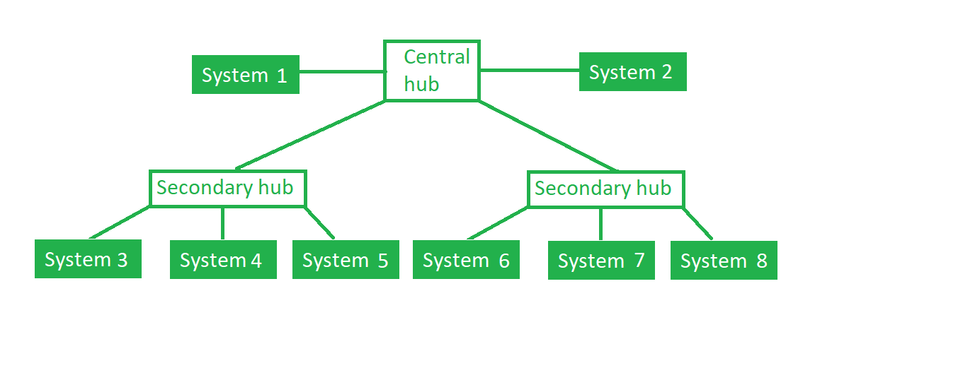**Advantages:**

* It allows more devices to be attached to a single central hub thus it decreases the distance that is traveled by the signal to come to the devices.
* It allows the network to get isolated and also prioritize from different computers.
* We can add **new devices to the existing network.**
* **Error detection** and **error correction** are very easy in a tree topology.

**Drawbacks:**

* If the central hub gets fails the entire system fails.
* The cost is high because of the cabling.
* If new devices are added, it becomes difficult to reconfigure.
* A common example of a tree topology is the hierarchy in a large organization.
* At the top of the tree is the CEO, who is connected to the different departments or divisions (child nodes) of the company.
* Each department has its own hierarchy, with managers overseeing different teams (grandchild nodes).
* The team members (leaf nodes) are at the bottom of the hierarchy, connected to their respective managers and departments.

### Hybrid Topology

* This topological technology is the combination of all the various types of topologies we have studied above.
* Hybrid Topology is used when the nodes are free to take any form. It means these can be individuals such as Ring or Star topology or can be a combination of various types of topologies seen above.
* Each individual topology uses the protocol that has been discussed earlier.

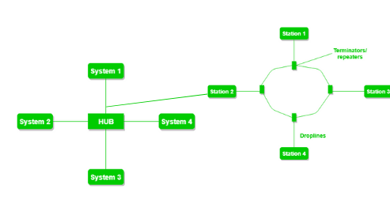

**Advantages:**

* This topology is **very flexible**.
* The size of the network can be easily expanded by **adding new devices.**

**Drawbacks:**

* It is challenging**to design the architecture** of the Hybrid Network.
* **Hubs**used in this topology are**very expensive.**
* The infrastructure cost is very high as a hybrid network **requires a lot of cabling and network devices**.
* A common example is a university campus network.
* The network may have a backbone of a star topology, with each building connected to the backbone through a switch or router.
* Within each building, there may be a bus or ring topology connecting the different rooms and offices.
* The wireless access points also create a mesh topology for wireless devices.
* This hybrid topology allows for efficient communication between different buildings while providing flexibility and redundancy within each building.

# Implementing Star Topology using Cisco Packet Tracer

* A star topology for a Local Area Network (LAN) is one in which each node is connected to a central connection point, such as a hub or switch.
* Whenever a node tries to connect with another node then the transmission of the message must be happening with the help of the central node.
* The best part of star topology is the addition and removal of the node in the network but too many nodes can cause suffering to the network.
* A Cisco packet tracer is a simulation tool that is used for understanding the networks.
* The best part of the Cisco packet tracer is its visualization you can see the actual flow of the message and understand the workflow of the network devices.
* Implementation of Star Topology using Cisco Packet Tracer is done using Switch.

**Step 1:**We have taken a switch and linked it to six end devices.

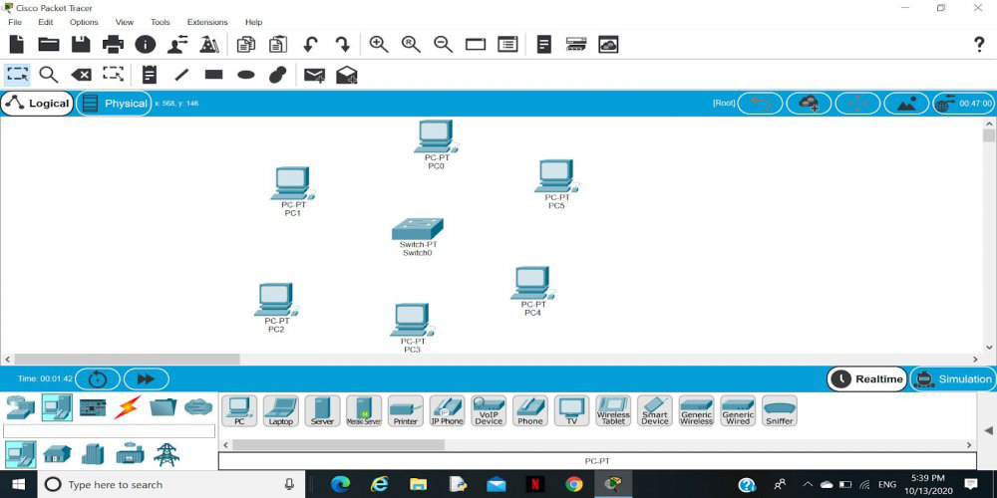

**Step 2:** Link every device with the switch.

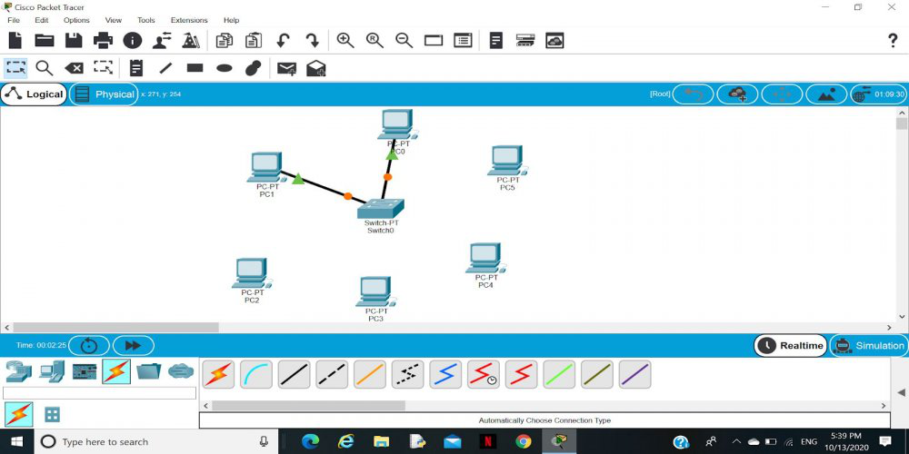

**Step 3:** Provide the IP address to each device.

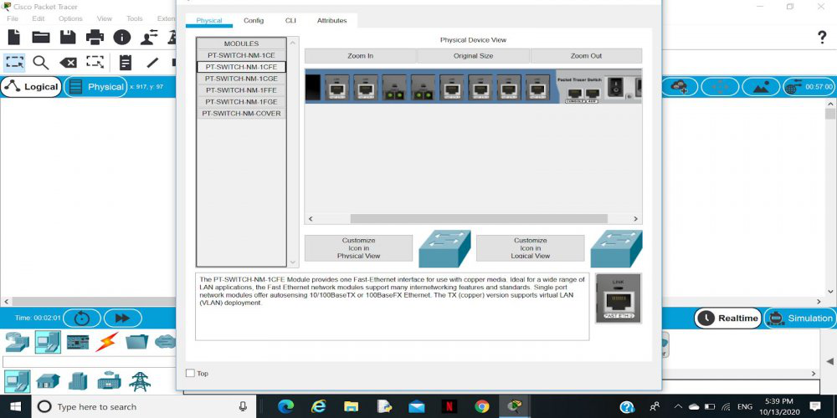

**Step 4:**Transfer message from one device to another and check the Table for Validation.

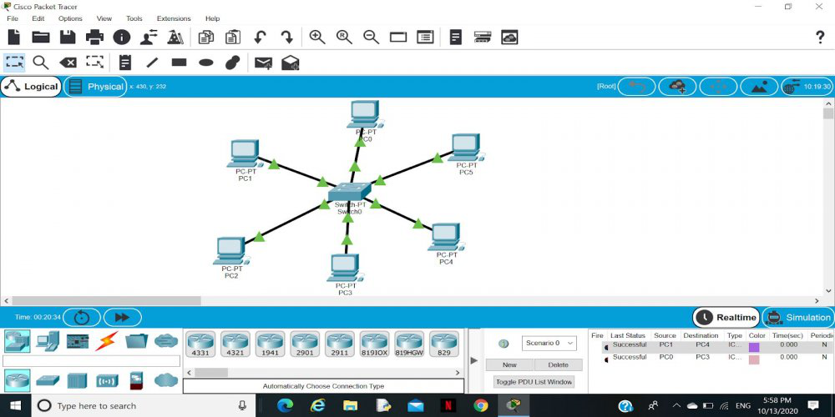

Now to check whether the connections are correct or not try to ping any device and the image below is doing the same.

To do ping one terminal of one device and run the following command:

**Command:**

"ping ip_address_of _any_device"

**Example:**

ping 192.168.1.4

Note:If the connections are correct then you will receive the response.

